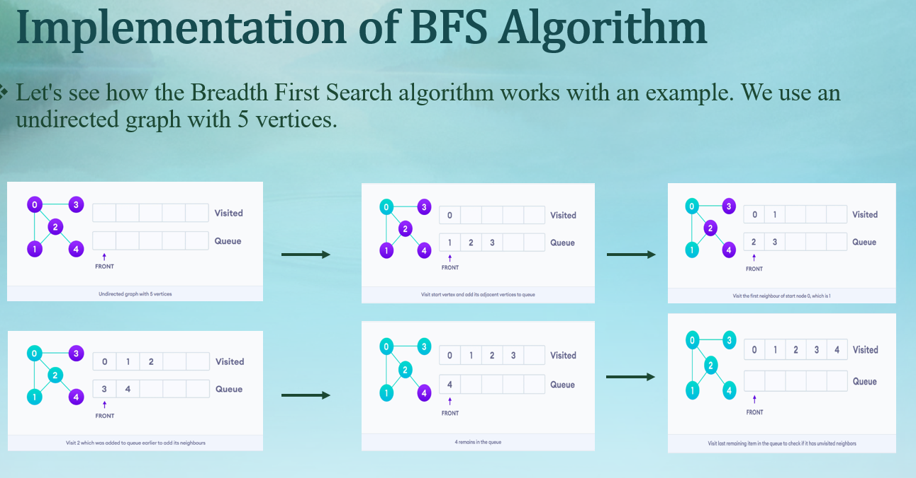

# BFS algorithm in Python

import collections

# BFS algorithm

def bfs(graph, root):

visited, queue = set(), collections.deque([root])

visited.add(root)

while queue:

# Dequeue a vertex from queue

vertex = queue.popleft()

print(str(vertex) + " ", end="")

# If not visited, mark it as visited, and

# enqueue it

for neighbour in graph[vertex]:

if neighbour not in visited:

visited.add(neighbour)

queue.append(neighbour)

graph = {0: [1, 2], 1: [2], 2: [3], 3: [1, 2]}

print("Following is Breadth First Traversal: ")

bfs(graph, 0)

